PRESS RELEASE
COMMUNICATIONS AND MEDIA TEAM OF THE 43RD ASEAN SUMMIT 2023
No.08/SP/TKM-ASEAN2023/ENG/8/2023

30th ASCC Delegates Served with Indonesian Culinary Delights
Jakarta, 30 August 2023 – Delegates of the 30th ASEAN Socio-Cultural Community (ASCC) meeting were treated to Indonesian delicacies during a gala dinner at the ballroom of The Langham Hotel, Jakarta, on Tuesday (29 August 2023).
“Four dishes were served at the ASCC Gala Dinner, including rujak salmon, Soto Lamongan, rendang, and mango pudding,” said Tantri Moerdopo who acted as the Master of Ceremony (MC) of the event to InfoPublik on Wednesday (30 August 2023).
Rujak salmon was served as the appetizer during the gala dinner. It uses grilled salmon as the special ingredient accompanied by a sweet and spicy sauce made from peanuts, fresh oranges, and a mixture of young lettuce, resulting in a unique blend of flavors.
A specialty from Lamongan, one of the regencies in East Java Province, called soto (Indonesian traditional soup) followed the appetizer. Every region in Indonesia has its own spin on this dish. In Lamongan, soto features broth, vermicelli noodles (soun), cabbage, and shredded chicken as its fillings.
Soto Lamongan often comes with rice and is accompanied by condiments such as sambal (spicy sauce) as well as fritters such as perkedel (potato fritters) or fried tempeh (fermented soybean cake).
The second dish is a world-famous specialty from Minangkabau in West Sumatra, rendang. In this dinner, the beef rendang is cut into small pieces and combined with potatoes, broccoli, and sweet corn.
This dish is renowned for its rich flavor and seasoning. Rendang’s seasoning is typically made from a mixture of toasted and grounded coconut along with a diverse array of spices.
The dessert of the evening was mango pudding with a soft texture. In its presentation, the mango pudding was complemented by a special lemon fruit gel, ganache made from Flores vanilla, and caramel tuile for added sweetness.
The four dishes impressed the ASCC delegates who attended the dinner. Many of them praised the flavors of the dishes.
According to the delegates, they tasted unique flavors from the distinctive Indonesian spices throughout the dinner reception. “After the gala dinner, many expressed their appreciation for the meal,” said Tantri. (Tri Antoro/Donna/Elvira Inda Sari/Wisnu Wardoyo/PR).
***
For more information, please contact:
Director General of Public Information and Communications of the Ministry of Communications and Informatics – Usman Kansong (0816785320).
Get more information at http://asean2023.id, https://infopublik.id/kategori/asean-2023, and https://indonesia.go.id/kategori/ragam-asean-2023

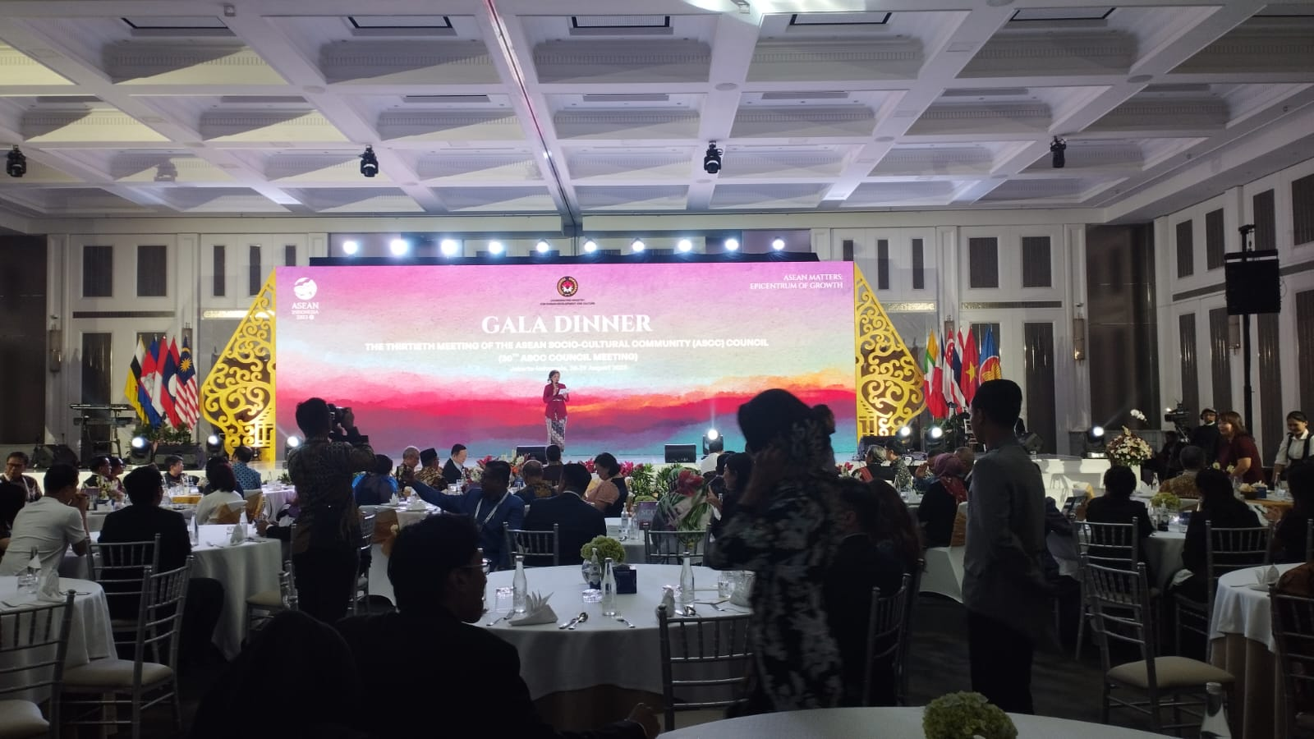
Delegates of the 30th ASEAN Socio-Cultural Community (ASCC) meeting are treated to Indonesian delicacies during a gala dinner at the ballroom of The Langham Hotel, Jakarta, on Tuesday (29 August 2023).

